|  |  |  |  |  |  |
| --- | --- | --- | --- | --- | --- |
| Date | 29-Nov-22 | | | Tester Name | Andrew McLaughlin |
| Environment | Penfax - Test | | | Login used |  |
| Operating System | Select OS | Version: | Update: | | |
| Software Used | Select Software | Version: | Update: | | |
| Select Software | Version: | Update: | | |
| Release version | 22.4.1 | | | | |
| Title | Death – Calculates retro amount, if any | | | | |
| Test Type | Regression | | | | |
| Test Scenario | Death – Calculates retro amount, if any | | | | |
|  |  | | | | |
| Expected Results | When a member’s death is discovered months after it has happened, the joint annuitant is retroactively entitled to the months of payments after the member passed away.   * We should be able to transfer the income benefit to the joint annuitant and they should get a retroactive payment for each month of payroll that has been run starting the month after the member passed away. | | | | |
| Pass/Fail | Pass | | | JIRA# | N/A |

Describe your steps with screenshots:

Member is with MEPP and has a bridge 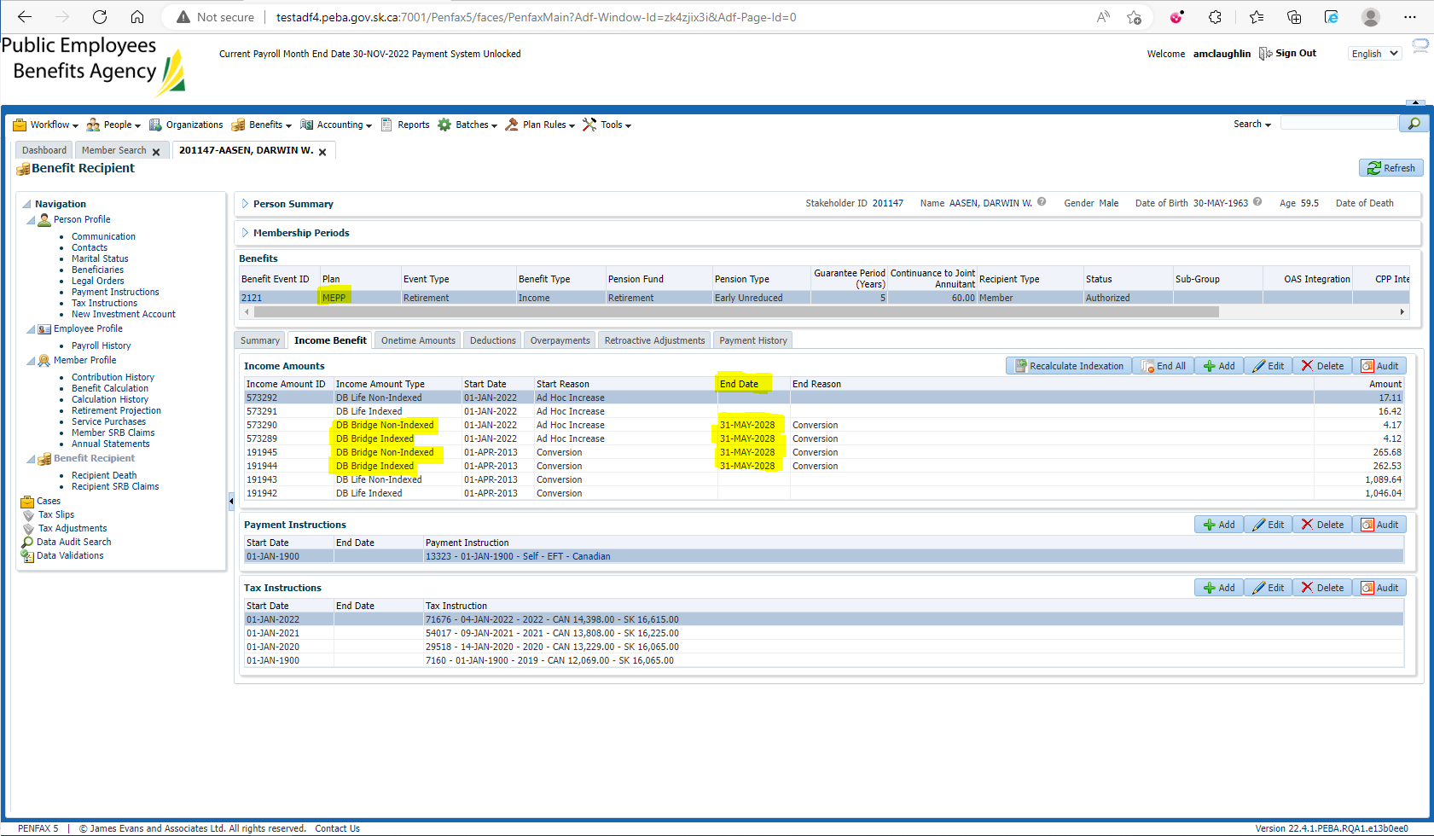

Pension amount is $2,705.71 with a 60% JA. GP Expired 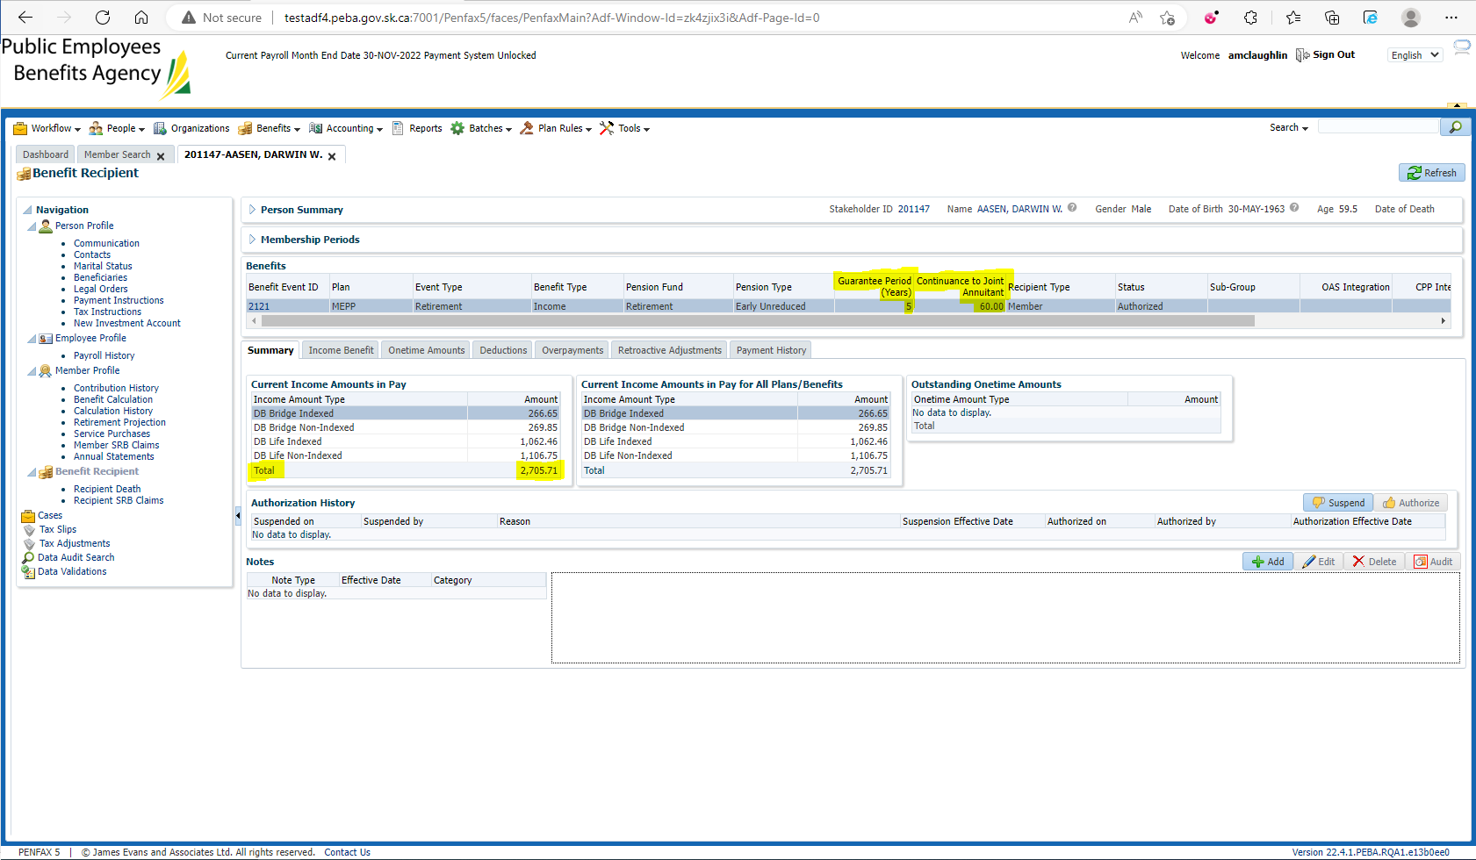

Enter Death Date 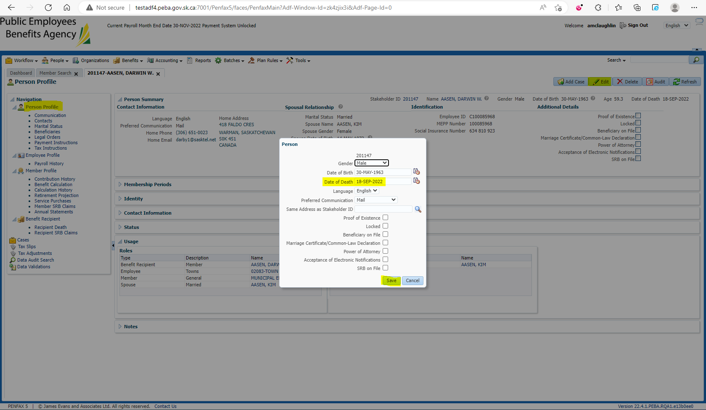

Add the spouse to the Benefit Recipients in the Benefit Event effective 1st day of month after death 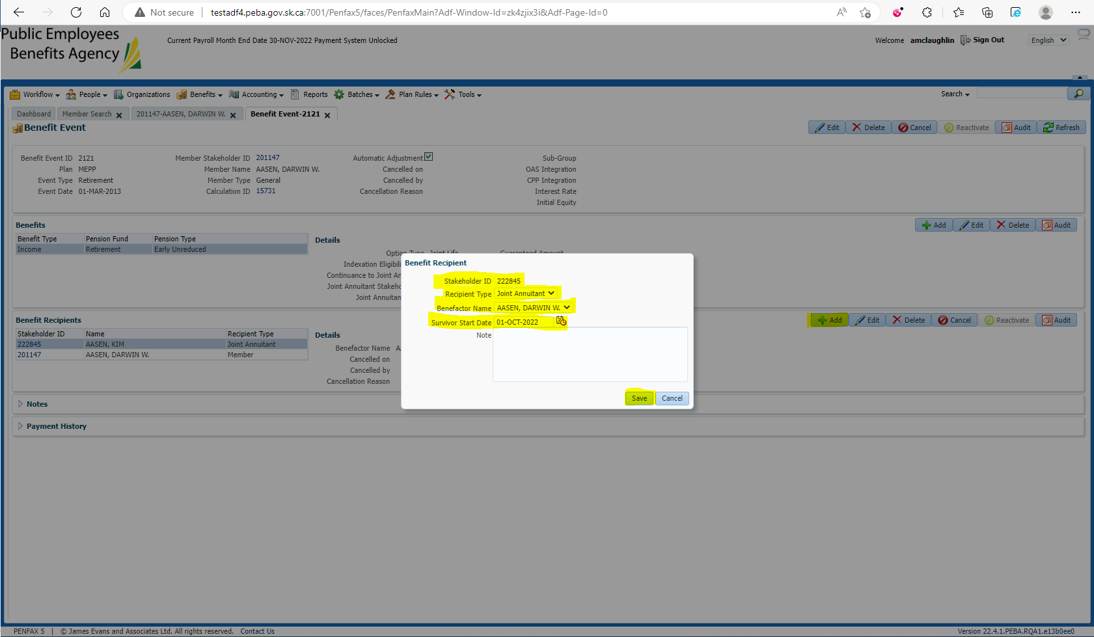

Open the Death Calc 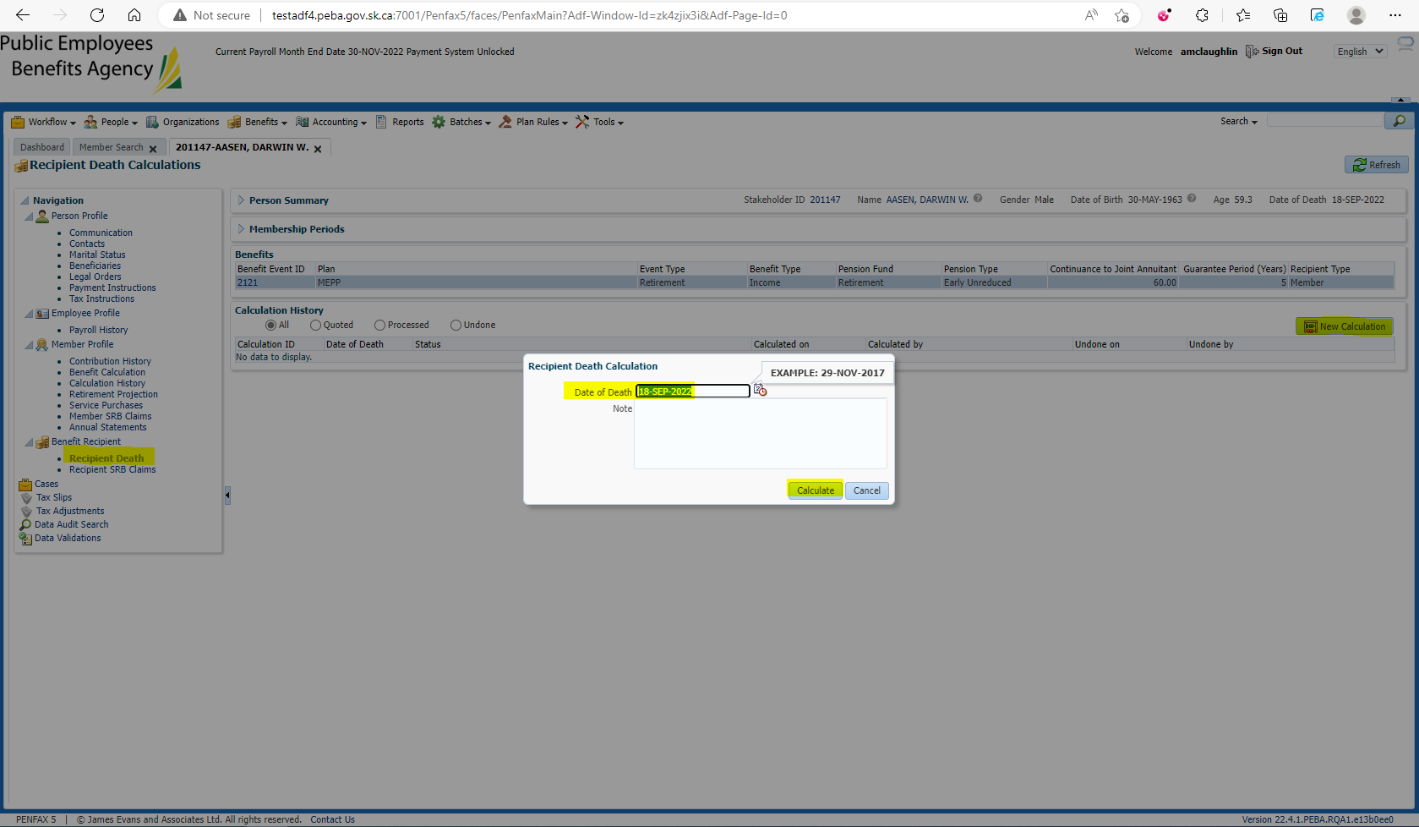

Process x2 and Process Recipient x2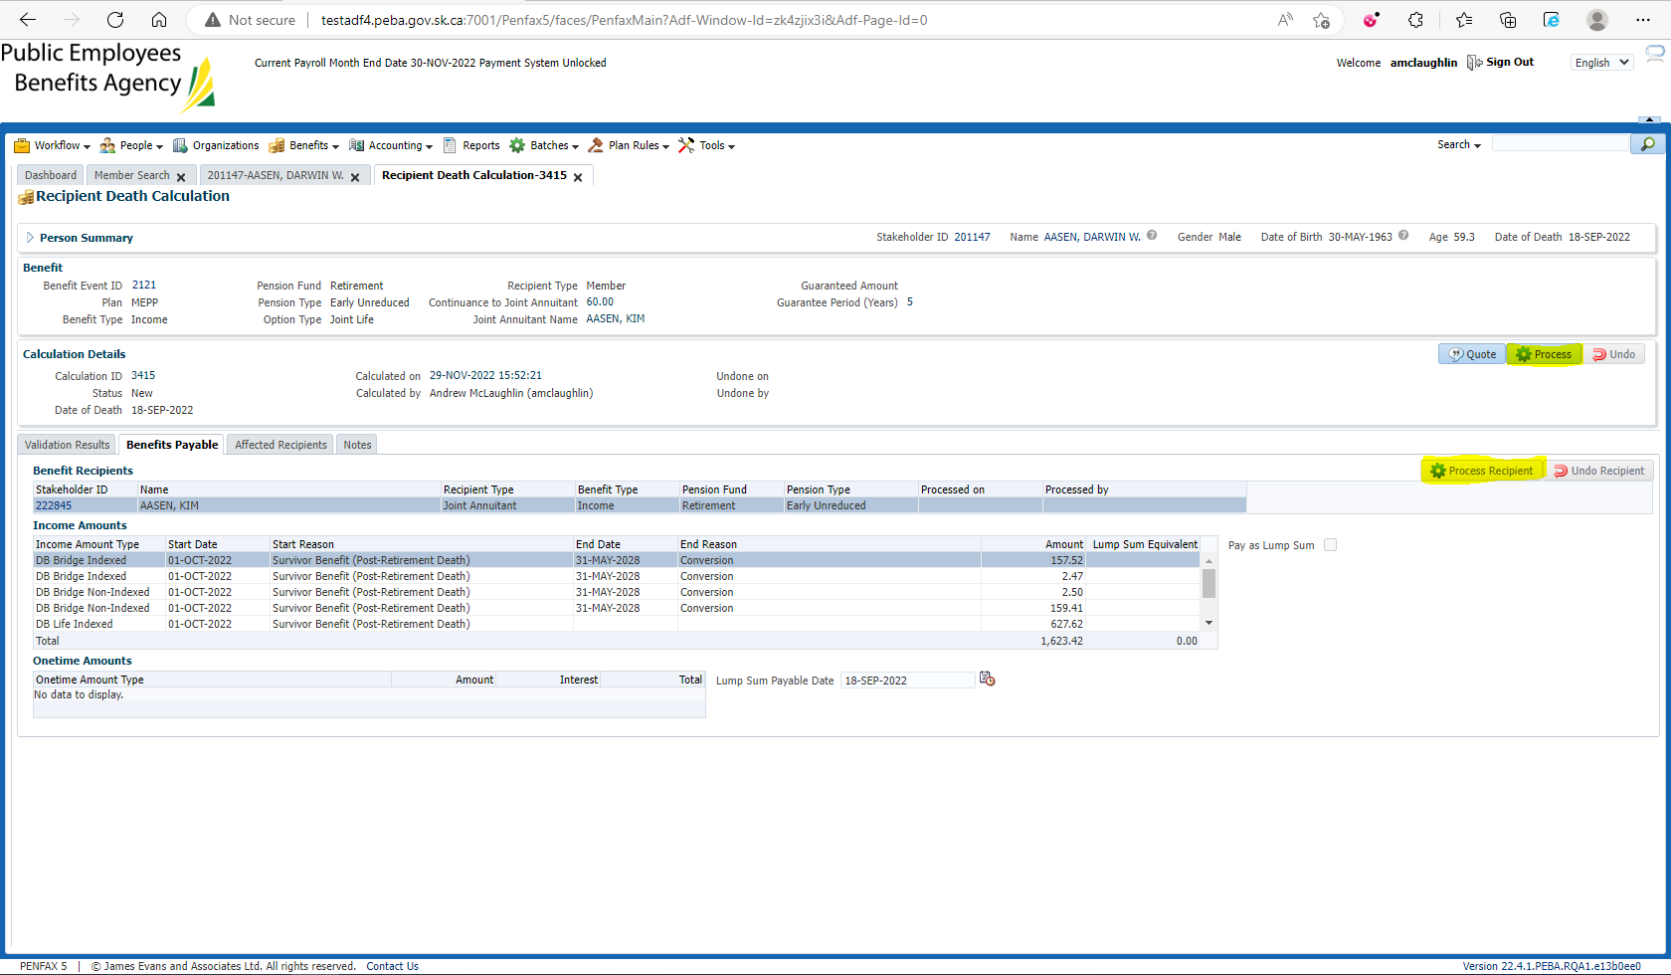

Process the Spouse’s Retroactive Adjustments 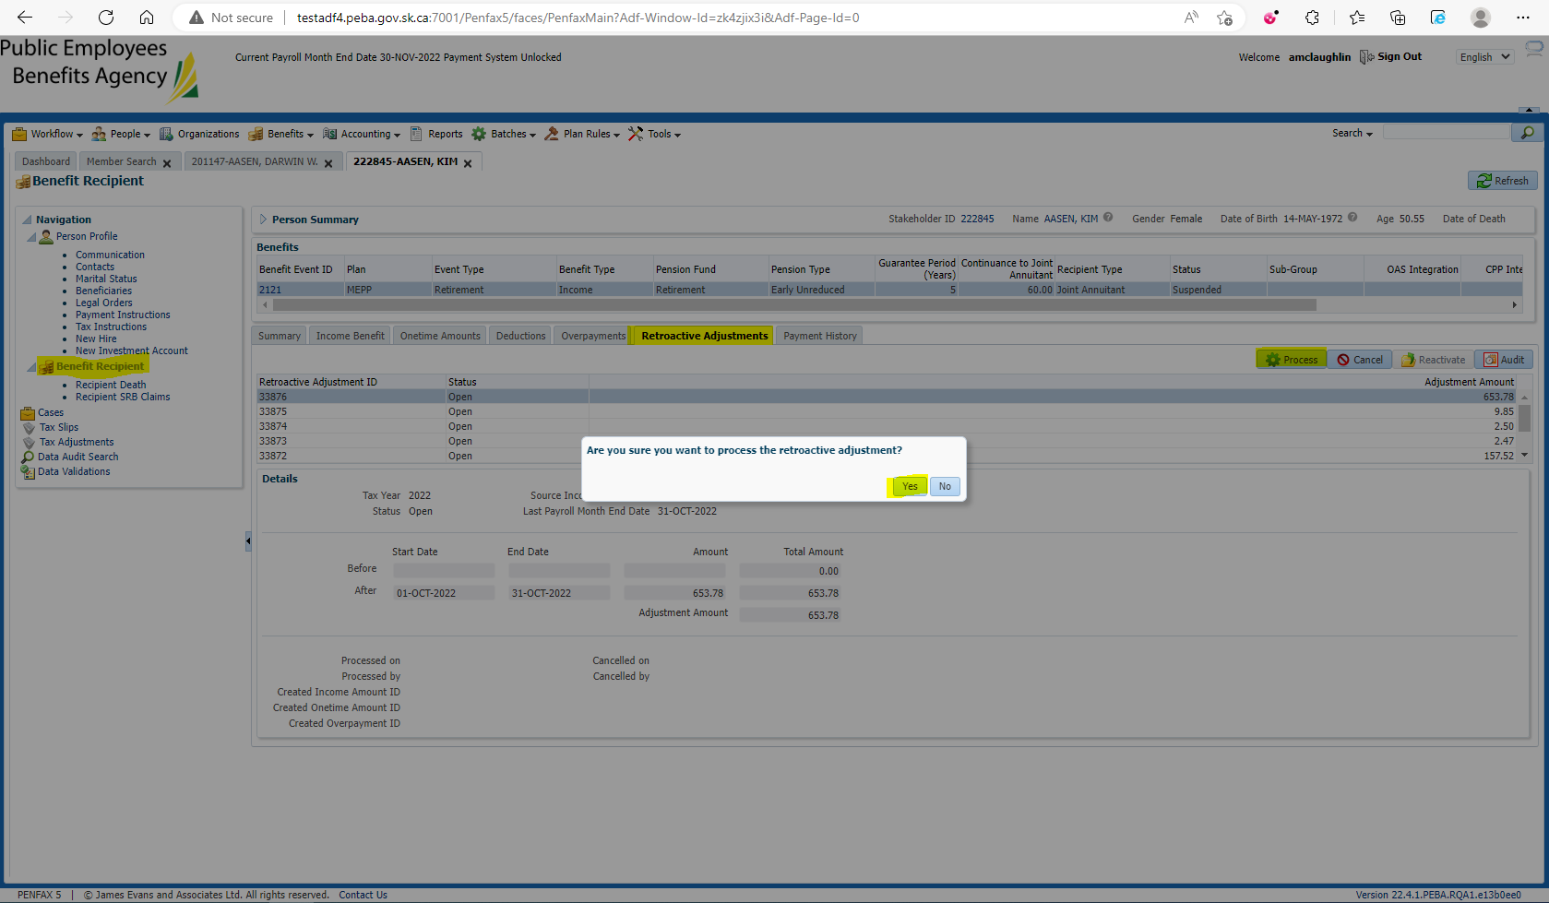

Verify under the spouse’s Benefit Recipient that they their retro payments are being calculated correctly: JA missed payments for October, so retro should = Current Income x1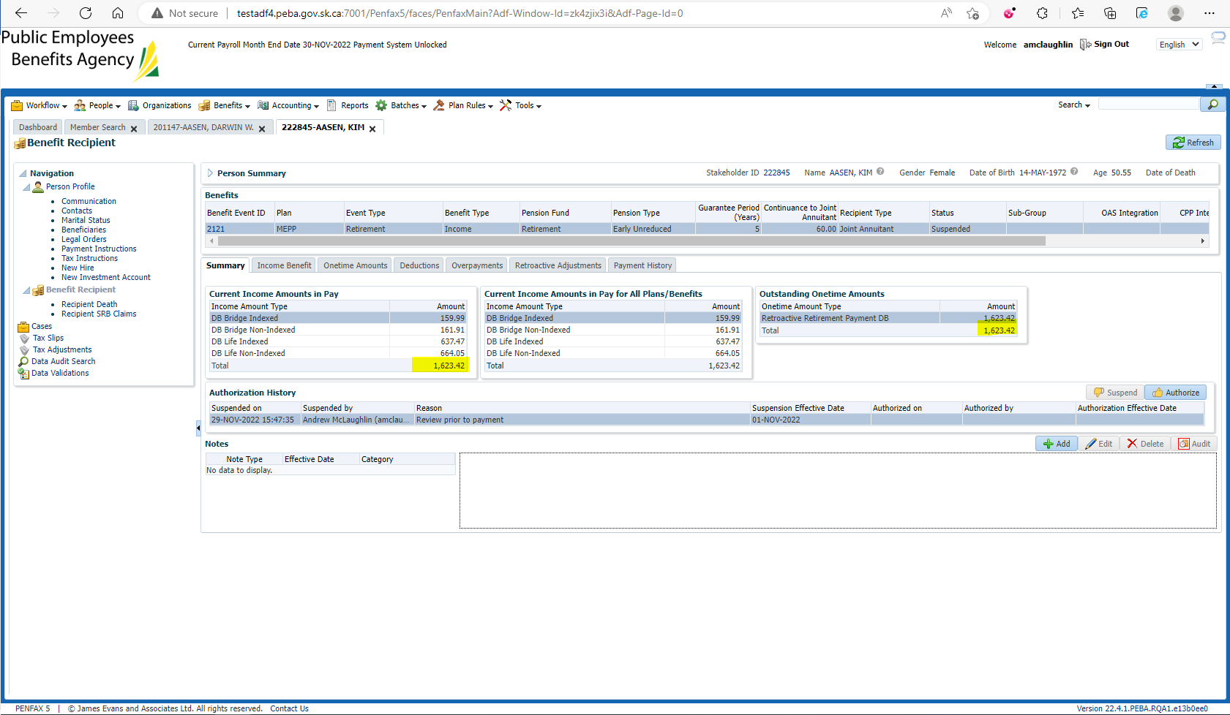

$1,623.42 * 1 = $1,623.42